

Applied Software Project Report

CollabGen — A Next-Generation Enterprise Collaboration Platform
By
Dharmaraj R

A Master’s Project Report submitted to Scaler Neovarsity - Woolf in partial fulfillment of the requirements for the degree of Master of Science in Computer Science

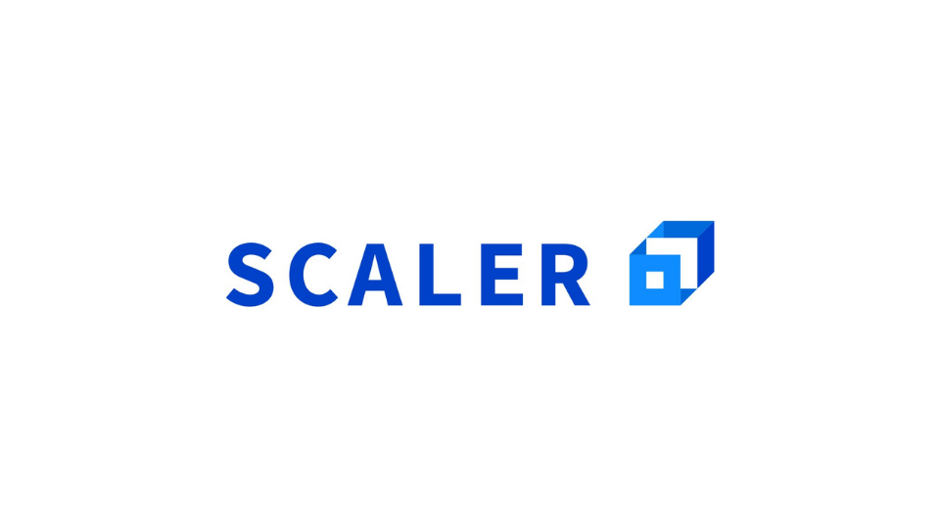
April 2026

Scaler Mentee Email ID: dharmaraj.171215@gmail.com
Thesis Supervisor: Naman Bhalla
Date of Submission: 14/04/2026

Certification

I confirm that I have overseen and reviewed this applied project and, in my judgment, it adheres to the appropriate standards of academic presentation. I believe it satisfactorily meets the criteria, in terms of both quality and breadth, to serve as an applied project report for the attainment of Master of Science in Computer Science degree. This applied project report has been submitted to Woolf and is deemed sufficient to fulfill the prerequisites for the Master of Science in Computer Science degree.

Naman Bhalla
.....................
Project Guide / Supervisor

Declaration

I confirm that this project report, submitted to fulfill the requirements for the Master of Science in Computer Science degree, completed by me from 07/07/2025 to 02/12/2025, is the result of my own individual endeavor. The Project has been made on my own under the guidance of my supervisor with proper acknowledgement and without plagiarism. Any contributions from external sources or individuals, including the use of AI tools, are appropriately acknowledged through citation. By making this declaration, I acknowledge that any violation of this statement constitutes academic misconduct. I understand that such misconduct may lead to expulsion from the program and/or disqualification from receiving the degree.

Dharmaraj R
 Date: 14 April 2026

Acknowledgment

I would like to express my sincere gratitude to all those who have contributed to the successful completion of this applied software project and the Master of Science in Computer Science program at Scaler Neovarsity – Woolf.
First and foremost, I extend my heartfelt thanks to my project supervisor, Naman Bhalla, for his invaluable guidance, constructive feedback, and constant encouragement throughout the development of CollabGen. His expertise in backend engineering and system design was instrumental in shaping the architectural decisions and quality standards of this project.
I am deeply grateful to the instructors and mentors at Scaler Academy for providing a rigorous and industry-relevant curriculum that equipped me with the theoretical foundations and practical skills necessary to undertake a project of this complexity. The knowledge gained in distributed systems, database design, API development, and cloud infrastructure proved indispensable during the implementation of CollabGen.
I would also like to acknowledge the open-source community and the developers of the technologies used in this project, including Spring Boot, React, PostgreSQL, Redis, and Amazon Web Services. Their documentation, forums, and community support significantly accelerated the development process.
Finally, I express my profound gratitude to my family and friends for their unwavering support, patience, and motivation throughout this academic journey. Their encouragement during challenging phases of development and study kept me focused on achieving this important milestone.

Table of Contents

List of Tables 6
List of Figures 7
1. Applied Software Project 8
1.1 Abstract 8
1.2 Project Description 10
1.3 Requirement Gathering 14
1.4 Class Diagrams 23
1.5 Database Schema Design 29
1.6 Feature Development Process 36
1.7 Deployment Flow 41
1.8 Technologies Used 45
1.9 Conclusion 49
References 52

List of Tables

Table No. | Title | Page No.
1.01 | Functional Requirements of CollabGen | 14
1.02 | Non-Functional Requirements of CollabGen | 15
1.03 | Core Feature Set – Communication Module | 19
1.04 | Core Feature Set – Organization Management Module | 20
1.05 | Core Feature Set – WorkDrive and File Management Module | 20
1.06 | Core Feature Set – Module Builder (CRM/Task Management) | 21
1.07 | Core Feature Set – Subscription and Payment Module | 21
1.08 | Core Feature Set – Recruitment Module | 22
1.09 | Database Tables and Descriptions | 34
1.10 | Real-Time Messaging API Endpoints | 38
1.11 | API Response Time Benchmarks | 40
1.12 | Technologies Used in CollabGen | 45

List of Figures

Figure No. | Title | Page No.
1.01 | CollabGen High-Level Architecture Diagram | 12
1.02 | User Registration and Authentication Flow | 13
1.03 | Use Case Diagram – Organization Member | 17
1.04 | Use Case Diagram – Organization Admin | 18
1.05 | Class Diagram – User and Organization Domain | 24
1.06 | Class Diagram – Chat and Messaging Domain | 25
1.07 | Class Diagram – Post and Feed Domain | 26
1.08 | Class Diagram – WorkDrive Domain | 27
1.09 | Class Diagram – Module Builder Domain | 28
1.10 | Database Entity-Relationship Diagram | 35
1.11 | Real-Time Chat Message Sequence Diagram | 38
1.12 | AWS Deployment Architecture Diagram | 44

Chapter 1: Applied Software Project

1.1 Abstract

CollabGen is a comprehensive, full-stack enterprise collaboration platform designed to unify communication, project management, file storage, and organizational administration within a single integrated application. The platform addresses the growing need for consolidated digital workspaces in modern organizations, where teams frequently rely on multiple disconnected tools for messaging, file sharing, task tracking, and human resource management, leading to fragmented workflows and reduced productivity.
The primary objective of this project is to design and implement a scalable, secure, and modular collaboration platform that can serve organizations of varying sizes. The backend is built using Spring Boot 3.3 with Java 17, leveraging Spring Data JPA for data persistence with PostgreSQL, Spring Security with JWT-based stateless authentication, and WebSocket (STOMP protocol) for real-time bidirectional communication. Redis is employed for session-aware caching, user presence tracking with time-to-live (TTL) key expiration, and pre-signed URL caching for Amazon S3 media storage. Payment processing is handled through Stripe integration for subscription management, and email notifications are dispatched via Spring Mail with SMTP.
The frontend is developed using React 18 with Redux Toolkit for centralized state management, React Router for client-side navigation, and SockJS with STOMP for WebSocket communication. The application features a rich user interface with real-time feeds, one-to-one and group chat, a hierarchical file management system (WorkDrive), a dynamic module builder for CRM-like record management, a recruitment pipeline, support ticketing, department and role-based access control, subscription plan management, and organizational analytics.
The project demonstrates the practical application of microservice-oriented monolithic architecture, the Model-View-Controller design pattern, the Strategy and Factory design patterns for extensibility, and industry-standard security practices. CollabGen can be applied across various industries including technology, education, healthcare, and finance to consolidate internal communication, streamline project execution, and improve operational efficiency. The platform serves as a viable alternative to proprietary collaboration suites and demonstrates how modern open-source technologies can be combined to deliver enterprise-grade software solutions.

1.2 Project Description

1.2.1 Project Overview
CollabGen (Collaboration Generator) is a next-generation enterprise collaboration platform that consolidates multiple productivity tools into a single unified application. The name reflects the platform’s core mission: to generate seamless collaboration across teams, departments, and entire organizations. In today’s digital workplace, organizations typically rely on a fragmented ecosystem of tools — one application for instant messaging, another for file storage, a separate system for project management, and yet another for HR-related workflows. This fragmentation leads to context-switching overhead, data silos, and communication gaps that directly impact productivity and organizational cohesion.
CollabGen addresses this challenge by providing an all-in-one platform that integrates real-time messaging (both one-to-one and group conversations), a social feed system with posts, comments, polls, and trending analytics, a hierarchical cloud-based file management system (WorkDrive) backed by Amazon S3, a customizable module builder for task and record management, a recruitment pipeline with candidate tracking, a support ticketing system, department and designation management, role-based access control with configurable permissions, subscription plan management with Stripe payment integration, and a user presence service powered by Redis.
1.2.2 Objectives
The key objectives of this project are as follows:
- To design and implement a scalable, multi-tenant collaboration platform supporting multiple organizations with isolated data and configurable permissions.
- To build a real-time communication system using WebSocket (STOMP over SockJS) for instant messaging with features such as message scheduling, reactions, media attachments, read receipts, and pinned messages.
- To develop a social feed system with post creation, commenting, liking, tagging, polling, bookmarking, and trending post/tag analytics using Strategy-based algorithms.
- To implement a secure file management system (WorkDrive) with personal, team, and organization-wide workspaces, backed by Amazon S3 with Redis-cached pre-signed URLs for optimized media delivery.
- To create a dynamic module builder that allows organizations to define custom data models with configurable fields, transitions, permissions, and views — effectively enabling CRM, project management, or any workflow-specific use case.
- To integrate Stripe for subscription management, supporting multiple billing intervals, trial periods, and payment link generation.
- To implement robust security using Spring Security with JWT-based stateless authentication, BCrypt password hashing, and role-based access control at both the organization and module levels.
- To employ Redis for user presence tracking using key expiration with TTL, caching of S3 pre-signed URLs, and real-time status broadcasting via Pub/Sub channels.
1.2.3 Relevance and Real-World Applications
The relevance of CollabGen extends across multiple industries and organizational contexts. In the technology sector, software development teams can use the platform for sprint management through the module builder, codebase discussions via group chat, and design asset management through WorkDrive. In the education sector, universities and training institutions can leverage the feeds system for announcements, the chat for student-faculty interaction, and the module builder for assignment tracking. In the healthcare sector, hospital administration teams can use the platform for shift management, inter-departmental communication, and patient case file sharing through the secure WorkDrive. In the finance and consulting sector, organizations can benefit from the recruitment pipeline, client engagement tracking through custom modules, and secure document management.
The platform’s multi-organization support with subscription-based access control makes it suitable for deployment as a Software-as-a-Service (SaaS) offering, allowing businesses to create and manage their own organizational workspaces with fine-grained role and permission configurations. The 7-day trial period for new organizations, coupled with tiered subscription plans (Basic, Pro, Enterprise, Endless), mirrors the monetization strategies of established collaboration platforms such as Slack, Microsoft Teams, and Zoho Workplace.
1.2.4 High-Level Architecture
CollabGen follows a layered monolithic architecture with clear separation of concerns across the Controller, Service, Repository, and Model layers. The backend exposes RESTful API endpoints versioned under /api/v1/ and WebSocket endpoints under /ws/ and /app/. The frontend is a single-page application (SPA) built with React that communicates with the backend exclusively through HTTP REST calls and WebSocket STOMP frames. The architecture is designed to be modular, allowing individual modules (Chat, Feed, WorkDrive, Modules, Recruit, Support) to be refactored into independent microservices in the future without requiring changes to the frontend API contract.
Figure 1.01 below illustrates the high-level architecture of the CollabGen platform, showing the interaction between the React frontend, the Spring Boot backend, PostgreSQL database, Redis cache, Amazon S3 storage, and the Stripe payment gateway.
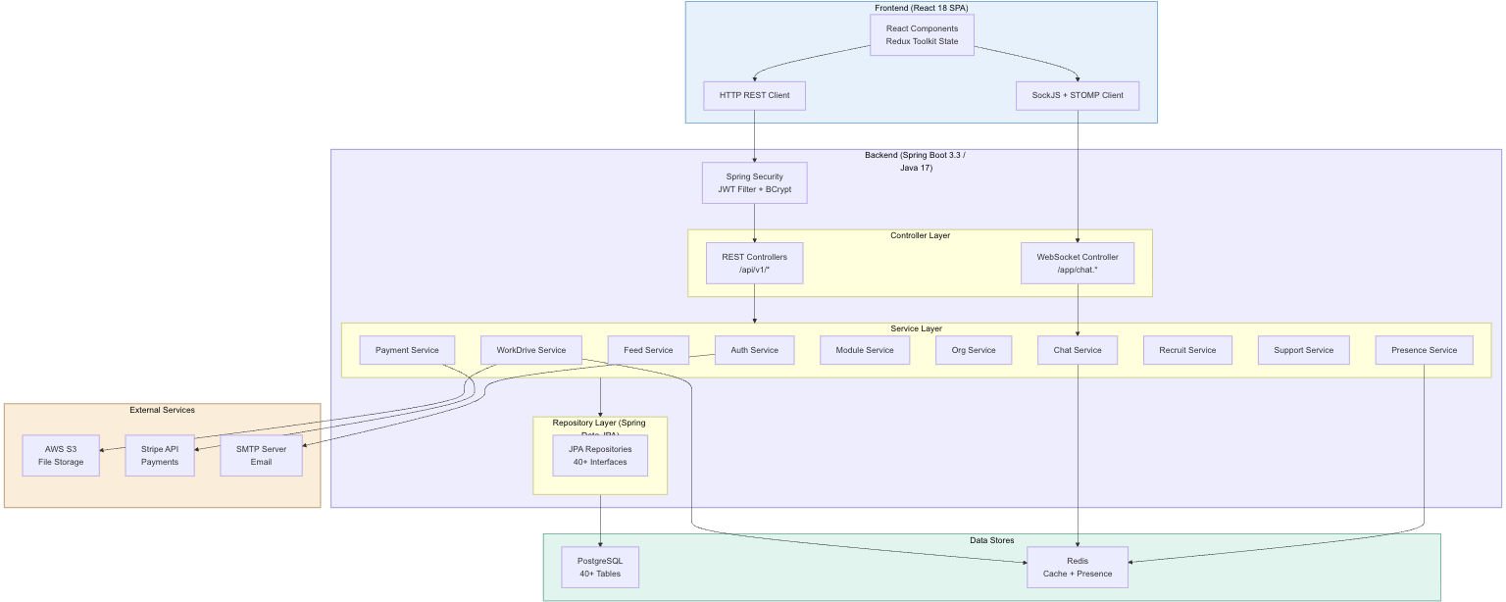
Figure 1.01: CollabGen High-Level Architecture Diagram

The authentication flow begins when a user submits their credentials to the /auth/login endpoint. The AuthService validates the credentials using Spring Security’s DaoAuthenticationProvider backed by a custom UserDetailsService that fetches user records from PostgreSQL. Upon successful authentication, a JWT token is generated using the HMAC-SHA256 algorithm and returned to the client. All subsequent API requests include this token in the Authorization header, and the JwtFilter intercepts each request to validate the token, extract the user’s identity, and set the SecurityContext for the request lifecycle.
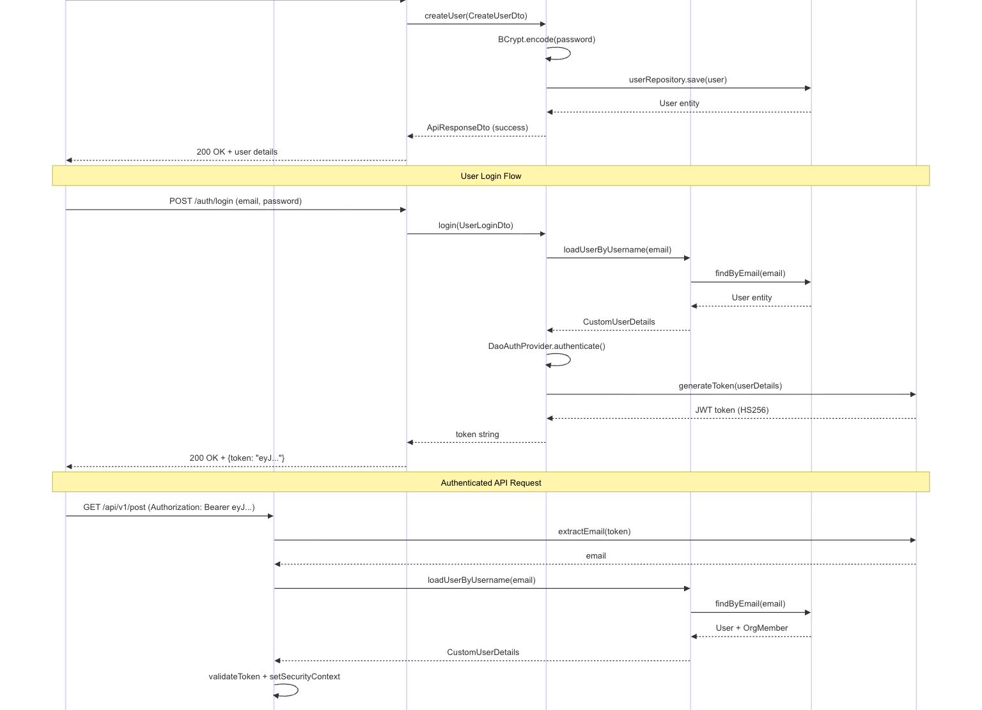
Figure 1.02: User Registration and Authentication Flow

1.3 Requirement Gathering

1.3.1 Functional Requirements
The functional requirements of CollabGen define the specific behaviors and capabilities that the system must provide to its users. These requirements were gathered through an analysis of existing collaboration platforms, identification of common organizational workflow pain points, and alignment with the Scaler Neovarsity curriculum’s emphasis on backend specialization topics including RESTful API design, database schema design, caching strategies, real-time communication, payment integration, and cloud-based file storage.

Table 1.01: Functional Requirements of CollabGen
Req. ID | Requirement Description | Priority
FR-01 | User registration with email, phone, and password with BCrypt encryption | High
FR-02 | JWT-based stateless authentication with configurable token expiration | High
FR-03 | Organization creation, update, deletion, and multi-org membership support | High
FR-04 | Role-based access control with configurable org-level permissions (invite, add, remove, update members) | High
FR-05 | Real-time one-to-one direct messaging with WebSocket (STOMP over SockJS) | High
FR-06 | Real-time group messaging with member management, visibility control, and message configuration | High
FR-07 | Message scheduling, rescheduling, unscheduling, and deletion of scheduled messages | Medium
FR-08 | Message reactions (emoji-based) for both direct and group messages | Medium
FR-09 | Message pinning for both direct and group conversations | Medium
FR-10 | Media file attachment support in chat messages with S3 storage | High
FR-11 | Read receipts and message status tracking (sent, delivered, read, deleted) | Medium
FR-12 | Post creation with title, description, media, polls, mentions, and tags | High
FR-13 | Post interactions: liking, commenting, replying, bookmarking, and sharing | High
FR-14 | Trending posts and trending tags analytics with Strategy-based algorithms | Medium
FR-15 | Post scheduling for deferred publication | Low
FR-16 | WorkDrive file management with personal, team, and organization workspaces | High
FR-17 | Folder hierarchy management with create, delete, restore, and clear operations | High
FR-18 | File upload to AWS S3, download, delete, and access statistics tracking | High
FR-19 | Pre-signed URL generation for S3 objects with Redis-cached URLs (5-minute TTL) | High
FR-20 | Starred files and public folder sharing | Medium
FR-21 | Dynamic module builder with customizable fields, transitions, permissions, and views | High
FR-22 | Module record CRUD with timeline tracking and relation-based field storage | High
FR-23 | Subscription plan management with Stripe integration for payment link generation | High
FR-24 | Organization subscription history tracking with trial period support | Medium
FR-25 | Email invitation system for onboarding new organization members | Medium
FR-26 | User presence service using Redis TTL-based key expiration with WebSocket broadcasting | Medium
FR-27 | Department and designation management for organizational hierarchy | Medium
FR-28 | Recruitment module with job openings, candidate tracking, and application timeline | Medium
FR-29 | Support ticketing system with ticket creation, comments, and attachments | Medium
FR-30 | Banner management for organization-wide announcements | Low

1.3.2 Non-Functional Requirements

Table 1.02: Non-Functional Requirements of CollabGen
Req. ID | Requirement Description | Category
NFR-01 | The system shall support concurrent real-time WebSocket connections for at least 500 simultaneous users per organization. | Scalability
NFR-02 | API response time for standard CRUD operations shall not exceed 200 milliseconds under normal load conditions. | Performance
NFR-03 | All passwords shall be stored using BCrypt encryption with a minimum cost factor of 10. | Security
NFR-04 | JWT tokens shall expire within a configurable time window (default: 24 hours) and shall be validated on every API request. | Security
NFR-05 | Pre-signed S3 URLs shall be cached in Redis with a 5-minute TTL to reduce S3 API calls and improve media delivery latency. | Performance
NFR-06 | User presence status shall be updated within 20 seconds of the last heartbeat signal, with automatic OFFLINE status upon key expiration. | Reliability
NFR-07 | The system shall enforce CORS restrictions allowing requests only from authorized frontend origins. | Security
NFR-08 | File uploads shall be limited to 5MB per file to manage S3 storage costs and bandwidth. | Resource Management
NFR-09 | The frontend shall render the initial authenticated view within 3 seconds on a standard broadband connection. | Performance
NFR-10 | The database schema shall use auto-increment identity generation for primary keys and UUID-based public identifiers for external-facing references. | Data Integrity

1.3.3 Users and Use Cases
CollabGen supports three primary user roles, each with distinct capabilities and access levels within the platform:

1. Organization Owner: The user who creates the organization. The owner has full administrative control, including the ability to configure organization-level permissions, manage subscription plans, add or remove members, create departments and designations, and delete the organization. The owner is automatically assigned the highest-privilege role upon organization creation.
2. Organization Admin: Members elevated to an administrative role by the owner. Admins can invite new members, manage roles and permissions based on their org configuration settings, moderate posts and chats, manage the WorkDrive team space, and configure module-level permissions. The specific permissions available to admins are configurable through the OrgConfiguration entity.
3. Organization Member: Standard members who can participate in chats, create and interact with posts, manage files in their personal workspace, use assigned modules, submit support tickets, and update their profile and presence status. Members have restricted access to administrative functions as defined by their assigned OrgRole.

The following use case diagrams illustrate the primary interactions of Organization Members and Organization Admins with the CollabGen platform.
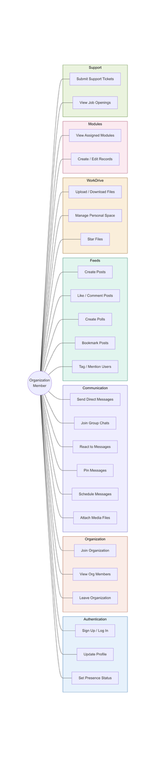
Figure 1.03: Use Case Diagram – Organization Member

An Organization Member can perform the following use cases: sign up and log in, create and join organizations, send and receive direct messages, participate in group chats, create posts with media and polls, comment on and like posts, upload and download files in personal WorkDrive, create and manage records in assigned modules, submit support tickets, update profile and presence status, and view recruitment job openings.
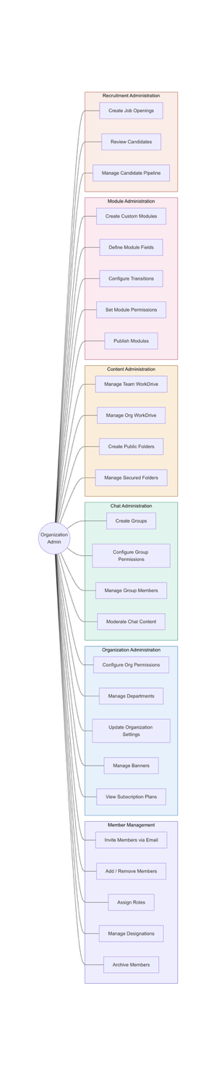

Figure 1.04: Use Case Diagram – Organization Admin

An Organization Admin inherits all member use cases and additionally can: invite members via email, assign and modify roles, configure organization-level permissions, manage departments and designations, create and configure group chats with permission settings, manage team and organization WorkDrive spaces, create and publish modules with custom fields and transitions, manage recruitment job openings and review candidates, manage subscription plans, and configure organization banners and announcements.

1.3.4 Feature Set
The complete feature set of CollabGen is organized into six core modules, each addressing a distinct aspect of organizational collaboration. The following tables detail the features within each module.

Table 1.03: Core Feature Set – Communication Module
Feature | Description | Key Technologies
Direct Messaging | Real-time 1:1 messaging with read receipts, reactions, pinning, media attachments, and message scheduling via WebSocket STOMP. | WebSocket, STOMP, SockJS, Redis
Group Messaging | Group chat with configurable visibility (public/private), member management, admin controls, message reactions, pinning, and media sharing. | WebSocket, STOMP, PostgreSQL
Bot Messages | System-generated bot messages for automated notifications and announcements within chat channels. | Spring Services, WebSocket
Presence Service | Real-time user availability tracking using Redis TTL key expiration with automatic offline detection after 20-second heartbeat timeout. | Redis, WebSocket Pub/Sub
Message Scheduling | Users can schedule messages for future delivery, reschedule or cancel scheduled messages, and view all pending scheduled messages. | Spring Scheduler, PostgreSQL

Table 1.04: Core Feature Set – Organization Management Module
Feature | Description | Key Technologies
Multi-Org Support | Users can create and join multiple organizations, each with isolated data, roles, and configurations. New organizations receive a 7-day trial. | Spring Data JPA, PostgreSQL
Role-Based Access | Configurable permission system at the org level (OrgConfiguration) with role definitions (OrgRole) controlling member management, group creation, and admin actions. | Spring Security, JWT
Email Invitations | Admin-initiated email invitations with unique acceptance links for onboarding new members into an organization. | Spring Mail, SMTP, JWT
Department Management | Hierarchical department structure with configurable settings for organizational grouping. | PostgreSQL, JPA Relationships
Designation Management | Employee designation/title management for organizational hierarchy display. | PostgreSQL, JPA
Org Configuration | Fine-grained action-level permission configuration (invite, add, remove, update members; update/delete org; create groups; show employee IDs). | PostgreSQL, Spring Services

Table 1.05: Core Feature Set – WorkDrive and File Management Module
Feature | Description | Key Technologies
Personal Space | Private file storage workspace accessible only to the individual user. | AWS S3, PostgreSQL
Team Space | Shared workspace for team-level file collaboration with folder hierarchy. | AWS S3, Spring Services
Organization Space | Organization-wide shared storage accessible based on member roles. | AWS S3, RBAC
File Operations | Upload, download, delete files with extension tracking, size tracking, and creator attribution. | AWS S3 SDK, MultipartFile
Folder Management | Create, delete, restore, and clear folders with parent-child hierarchy support. | PostgreSQL, Recursive JPA
Pre-signed URLs | Secure, time-limited S3 access URLs cached in Redis (5-min TTL) for optimized media delivery. | AWS S3 Presigner, Redis
Starred Files | Users can star/bookmark frequently accessed files for quick retrieval. | PostgreSQL, JPA
Public Folders | Folders can be made publicly accessible with shareable links. | PostgreSQL, Spring Services
Access Statistics | File access tracking for usage analytics and audit purposes. | PostgreSQL, JPA
Secured Folders | Permission-based folder access control for sensitive documents. | Spring Security, PostgreSQL

Table 1.06: Core Feature Set – Module Builder (CRM/Task Management)
Feature | Description | Key Technologies
Custom Modules | Organizations can create custom modules with configurable names, descriptions, and accessibility settings (public/private/restricted). | Spring Services, PostgreSQL
Dynamic Fields | Modules support 10+ field types: String, Phone, DateTime, Currency, GeoLocation, File, User, Select, Link, and Transition fields. | JPA, Factory Pattern
Transitions | State-based transitions for workflow management (e.g., To Do → In Progress → Done). | PostgreSQL, Strategy Pattern
Permissions | Module-level role-based permissions (Owner, Admin, Member) with field-level visibility and editability control. | Spring Security, RBAC
Record Management | CRUD operations on module records with timeline tracking for audit trails. | PostgreSQL, JPA
Views | Configurable views including List and Kanban for visualizing module records. | React, Redux

Table 1.07: Core Feature Set – Subscription and Payment Module
Feature | Description | Key Technologies
Subscription Plans | Tiered plans (Basic, Pro, Enterprise, Endless) with configurable pricing, intervals (monthly/yearly), and feature limits. | PostgreSQL, Spring Services
Stripe Integration | Payment link generation, subscription creation, and webhook handling for payment status updates. | Stripe Java SDK, Webhooks
Trial Period | 7-day (configurable up to 730 days) trial period for new organization subscriptions. | Spring Services, Stripe
Transaction History | Complete payment transaction tracking with status (initiated, completed, failed) and gateway details. | PostgreSQL, JPA
Subscription History | Organization-level subscription history with plan details, start/end dates, and renewal tracking. | PostgreSQL, Spring Services

Table 1.08: Core Feature Set – Recruitment Module
Feature | Description | Key Technologies
Job Openings | Create and manage job openings with title, description, location, budget, job type, positions available, and application criteria. | PostgreSQL, Spring Services
Candidate Tracking | Track candidates through application stages with status management (Applied, Screening, Interview, Offer, Rejected, Hired). | PostgreSQL, JPA Enums
Candidate Timeline | Chronological activity log for each candidate tracking all status changes and interactions. | PostgreSQL, JPA
Referral System | Internal referral support allowing existing members to refer candidates for open positions. | PostgreSQL, JPA Relationships
Job Filtering | Advanced filtering by job type, status, location, and other criteria for efficient job management. | Spring Data JPA, Specifications

1.4 Class Diagrams

This section presents the low-level design of CollabGen through detailed class diagrams organized by domain. The project follows a layered architecture with a strict separation of concerns: Model classes define the data structure, Repository interfaces handle database access, Service interfaces and implementations contain business logic, Controller classes expose REST endpoints, and DTO (Data Transfer Object) classes facilitate data exchange between layers. The project comprises 596 Java source files organized across these layers.

1.4.1 Class Diagram – User and Organization Domain
The User and Organization domain forms the foundation of CollabGen’s multi-tenancy model. The core entity hierarchy begins with BaseModel, which provides an auto-incremented Long primary key. PublicAccessModel extends BaseModel to add a randomly generated publicId string (used for external API references to avoid exposing internal database IDs) and a createdAt timestamp. UUIDBaseModel provides an alternative UUID-based primary key for entities requiring globally unique identifiers.
The User entity stores core user credentials (email, phone, encrypted password) and a system-level Role enum. The Org entity represents an organization with a displayName, uniqueName, owner reference, and active status. The OrgMember entity serves as the central pivot between User and Org, storing the member’s display name, employee ID, OrgRole, Designation, Department, manager reference, display picture, archived status, last login timestamp, and MemberStatus (ONLINE, OFFLINE, AWAY, DO_NOT_DISTURB). The OrgRole entity defines named roles with associated OrgAction permissions. The OrgConfiguration entity stores fine-grained permission mappings for each role within an organization.
The OrgInvitation entity manages email-based member invitations with InvitationStatus tracking (PENDING, ACCEPTED, REJECTED, EXPIRED). The Department and Designation entities provide organizational hierarchy management. The UserOnboarding entity tracks the onboarding state of new users.
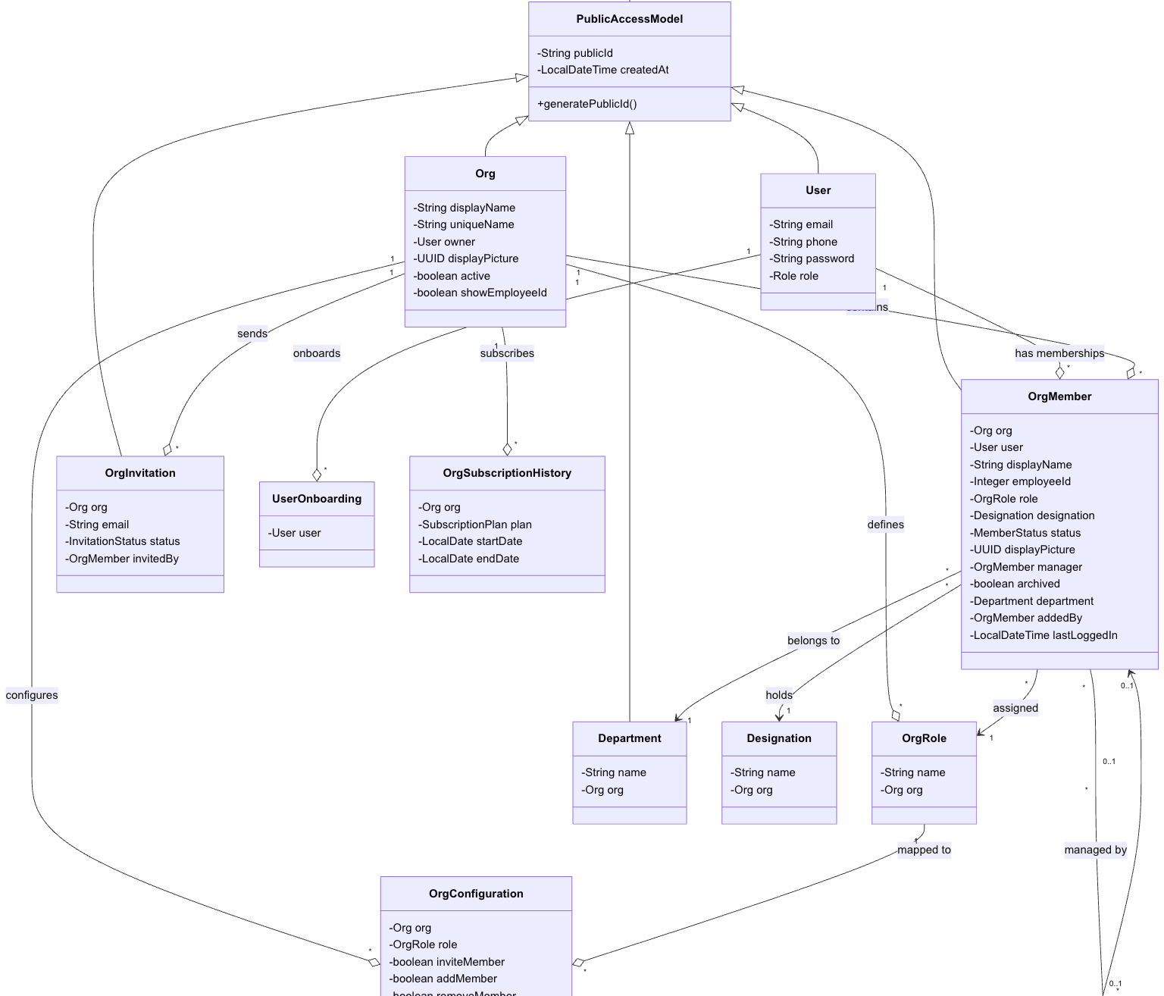
Figure 1.05: Class Diagram – User and Organization Domain

1.4.2 Class Diagram – Chat and Messaging Domain
The Chat domain implements both one-to-one and group messaging with a shared architectural pattern. The DirectMessage entity stores sender and receiver OrgMember references, message content, media flag, MessageStatus (SENT, DELIVERED, READ, DELETED, SCHEDULED), MessageType (USER_MESSAGE, BOT_MESSAGE, SYSTEM_MESSAGE), and ReadReceipt tracking. The DirectMessageChat entity groups conversations between two users, and DirectMessageReaction stores emoji-based reactions linked to individual messages. DirectMessageMediaFile tracks media attachments uploaded via S3. PinnedDirectMessage allows users to pin important messages for quick access.
The Group entity defines group chat channels with name, description, owner, Visibility (PUBLIC or PRIVATE), and a flag for showing old messages to new joiners. GroupChatMember tracks membership with the last-read message pointer for efficient unread count calculation. GroupChatMessage mirrors DirectMessage with group-level scoping. GroupChatConfiguration stores per-group permission settings (who can send messages, add members, and modify group settings). GroupChatReaction, GroupChatPinned, GroupMessagePinned, and GroupMessageMediaFile provide reaction, pinning, and media capabilities. The Bot entity supports automated bot messages with associated BotMessage and BotMessageMedia entities.
The WebSocketController class handles real-time message dispatch via STOMP message mappings (/app/chat.direct-message and /app/chat.group-message). The ChatServiceFactory implements the Factory pattern to resolve the appropriate ChatService implementation based on the ChatMode enum (DIRECT_MESSAGE or GROUP_MESSAGE). Each ChatService implementation handles message persistence, validation, and broadcasting via SimpMessagingTemplate.
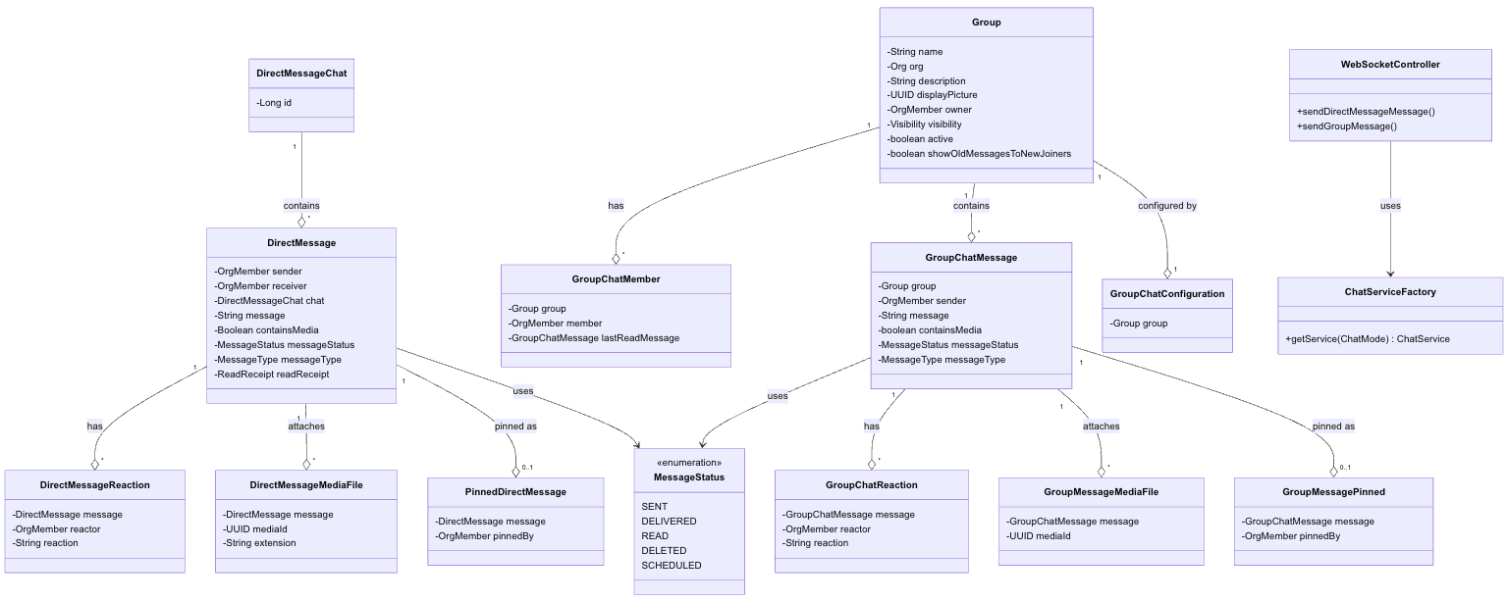
Figure 1.06: Class Diagram – Chat and Messaging Domain

1.4.3 Class Diagram – Post and Feed Domain
The Post domain implements a social feed system. The Post entity stores org and creator references, title, description (up to 3000 characters), media flag, poll flag, PostStatus (PUBLISHED, DRAFT, ARCHIVED, DELETED, SCHEDULED), and boolean flags for commentable, shareable, bookmarkable, and allowAnonymousComments. PostMedia, PostTag, PostMention, PostLike, PostComment, and PostReply entities manage associated interactions. The Bookmark entity enables users to save posts for later access. The Poll entity supports polls with PollOption and PollVoter entities. The Tag entity and TagService manage hashtag-based content categorization.
The feed retrieval system uses the Strategy pattern through FeedRetrieverServiceFactory and FeedRetrieverService interface, with SimpleFeedRetrieverService as the default implementation. Trending analytics are similarly Strategy-based: TrendingPostsAnalyserFactory resolves between EngagementBasedTrendingPostsAnalyser and WindowBasedTrendingPostsAnalyser, while TrendingTagsAnalyserFactory resolves between MostPostTrendingTagsAnalyser and WindowBasedTrendingTagsAnalyser. The FeedsController orchestrates feed retrieval, trending content, and quote-of-the-day functionality.
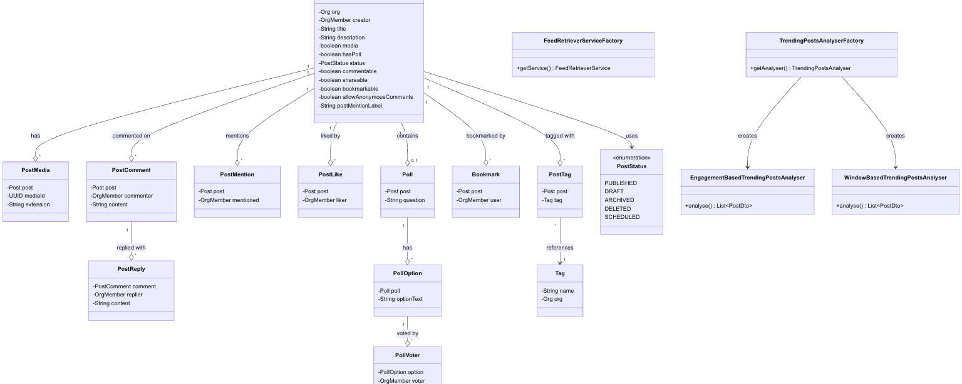
Figure 1.07: Class Diagram – Post and Feed Domain

1.4.4 Class Diagram – WorkDrive Domain
The WorkDrive domain implements a hierarchical file management system. The Folder entity stores name, creator, size, Workspace enum (PERSONAL, TEAM, ORGANIZATION), parentFolder reference (self-referencing ManyToOne for hierarchy), and soft-delete flag. The File entity stores name, folder reference, size, creator, mediaId (UUID linking to S3 object), extension, Security level, and soft-delete flag. FileAccessStat tracks file access events for analytics. StarredFile allows users to star frequently used files. PublicFolder enables public sharing of folder contents. SecuredFolderPermission manages permission-based access to sensitive folders. TeamFolder associates folders with team-level access control.
The S3Service class implements the MediaService interface using the AWS SDK v2 for S3 operations. It handles file upload (converting MultipartFile to S3 PutObject), download (GetObjectAsBytes), deletion, and pre-signed URL generation using S3Presigner. Pre-signed URLs are cached in Redis with a 5-minute TTL to reduce S3 API calls; the cache key format is s3-presigned-url:{mediaId}. The FileHelper utility class provides file type classification and validation.
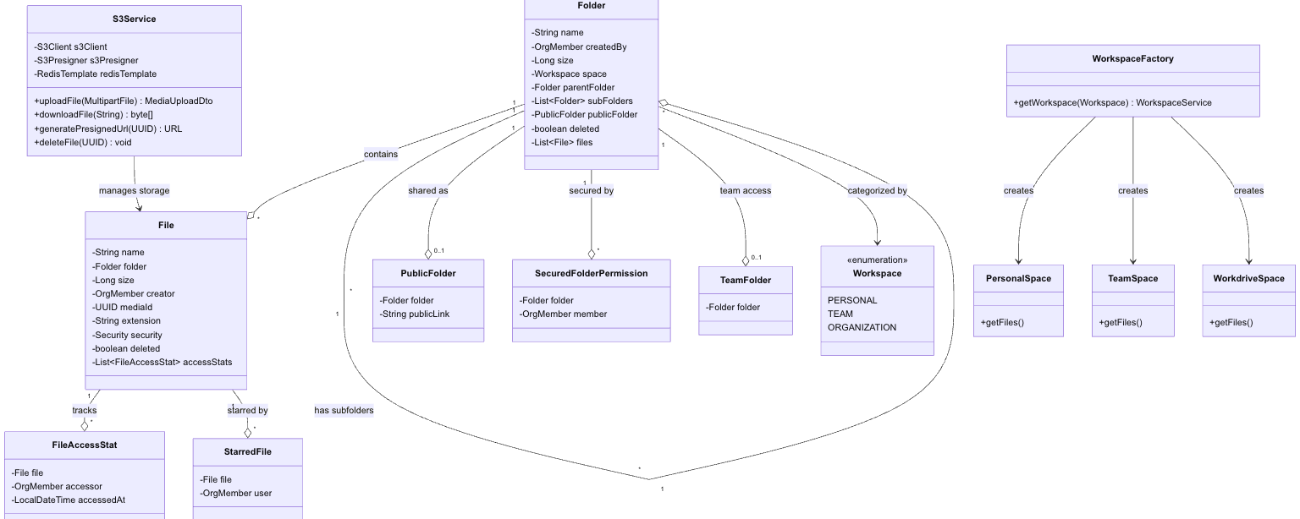
Figure 1.08: Class Diagram – WorkDrive Domain

1.4.5 Class Diagram – Module Builder Domain
The Module Builder domain provides a dynamic, configurable data model system. The Module entity stores name, description, creator, ModuleAccessibility (PUBLIC, PRIVATE, RESTRICTED), and flags for duplicate subject allowance and relation openness. ModuleField defines the schema for each module with name, FieldType (STRING, PHONE, DATE_TIME, CURRENCY, GEO_LOCATION, FILE, USER, SELECT, LINK, TRANSITION), FieldClassification (PREDEFINED_FIELD, USER_DEFINED_FIELD), and boolean flags for required, searchable, filterable, sortable, editable, showInList, and showInDetail. Field-level access restrictions are managed through a list of ModuleRole enums.
ModuleRecord represents individual records within a module. The record data is stored in a polymorphic fashion through Record*Relation entities: RecordStringRelation, RecordPhoneRelation, RecordDateTimeRelation, RecordCurrencyRelation, RecordGeoLocationRelation, RecordFileRelation, RecordUserRelation, RecordSelectRelation, RecordLinkRelation, and RecordTransitionRelation. Each relation entity stores the field reference, record reference, and the typed value. The RecordRelationFactory resolves the appropriate RecordRelationService implementation based on the FieldType. Transition entities define state workflows for transition-type fields with source and target states. ModuleMember manages module membership with ModuleRole-based permissions (OWNER, ADMIN, MEMBER). ModulePermission provides fine-grained CRUD permission control at the module level. ModuleRecordTimeline tracks audit events on individual records.
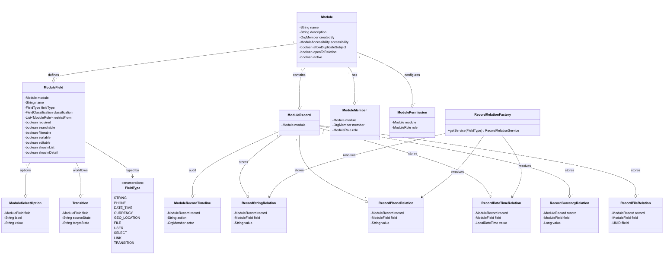
Figure 1.09: Class Diagram – Module Builder Domain

1.5 Database Schema Design

CollabGen uses PostgreSQL as its primary relational database management system. The schema is managed through Spring Data JPA with Hibernate as the ORM provider, using the ddl-auto=update strategy for schema evolution during development. The database design follows normalization principles up to Third Normal Form (3NF) while incorporating strategic denormalization for performance-critical read paths. All entities use auto-incremented BIGINT primary keys internally and expose randomly generated string-based publicId values for external API references, ensuring that internal database identifiers are never exposed to clients.
The database comprises over 40 interconnected tables spanning six functional domains. The following subsections describe the schema textually and provide relationship cardinality mappings.

1.5.1 User and Authentication Tables
The users table stores core user credentials and serves as the identity anchor for the entire system.

users
- id (BIGINT, PK, auto-increment)
- public_id (VARCHAR, UNIQUE, NOT NULL) – External reference identifier
- email (VARCHAR, UNIQUE, NOT NULL)
- phone (VARCHAR, UNIQUE, NOT NULL)
- password (VARCHAR, NOT NULL) – BCrypt-encrypted
- role (VARCHAR, ENUM: USER, ADMIN)
- created_at (TIMESTAMP, NOT NULL)

user_onboarding
- id (BIGINT, PK, auto-increment)
- user_id (BIGINT, FK → users.id)
- Tracks onboarding state for new users

1.5.2 Organization Tables
org
- id (BIGINT, PK), public_id (VARCHAR, UNIQUE)
- display_name (VARCHAR, NOT NULL), unique_name (VARCHAR, UNIQUE, NOT NULL)
- owner_id (BIGINT, FK → users.id), display_picture (UUID)
- active (BOOLEAN), show_employee_id (BOOLEAN), created_at (TIMESTAMP)

org_member
- id (BIGINT, PK), public_id (VARCHAR, UNIQUE)
- org_id (BIGINT, FK → org.id), user_id (BIGINT, FK → users.id)
- display_name (VARCHAR, NOT NULL), employee_id (INTEGER, NOT NULL)
- role_id (BIGINT, FK → org_role.id), designation_id (BIGINT, FK → designation.id)
- department_id (BIGINT, FK → department.id), manager_id (BIGINT, FK → org_member.id)
- status (VARCHAR, ENUM), display_picture (UUID), archived (BOOLEAN)
- added_by_id (BIGINT, FK → org_member.id), last_logged_in (TIMESTAMP)

org_role
- id (BIGINT, PK), name (VARCHAR), org_id (BIGINT, FK → org.id)
- Defines named roles with associated actions

org_configuration
- id (BIGINT, PK), org_id (BIGINT, FK → org.id), role_id (BIGINT, FK → org_role.id)
- Permission flags: invite_member, add_member, remove_member, update_member, update_org, delete_org, leave_org, create_group

org_invitation
- id (BIGINT, PK), org_id (BIGINT, FK → org.id)
- email (VARCHAR), status (ENUM: PENDING, ACCEPTED, REJECTED, EXPIRED)
- invited_by (BIGINT, FK → org_member.id)

org_subscription_history
- id (BIGINT, PK), org_id (BIGINT, FK → org.id)
- plan_id (BIGINT, FK → subscription_plan.id), start_date, end_date, created_at

1.5.3 Chat and Messaging Tables
The messaging schema is split into direct message and group message domains.

direct_message_chat – Groups conversations between two OrgMembers.
direct_message – Stores individual messages with sender_id, receiver_id, direct_message_chat_id, message content, contains_media flag, message_status, message_type, and read_receipt.
direct_message_reaction – Emoji reactions on direct messages.
direct_message_media_file – Media attachments linked to direct messages.
pinned_direct_message – Pinned messages within direct conversations.

groups – Group chat entity with name, org_id, owner_id, visibility, and configuration flags.
group_chat_member – Group membership with last_read_message_id pointer.
group_chat_message – Group messages with sender, message content, media flag, status, and type.
group_chat_configuration – Per-group permission settings.
group_chat_reaction, group_chat_pinned, group_message_pinned, group_message_media_file – Reactions, pins, and media for group messages.

1.5.4 Post and Feed Tables
post – Core feed entity with org_id, creator_id, title, description (3000 chars), status, and interaction flags.
post_media, post_tag, post_mention, post_like, post_comment, post_reply – Media, tags, mentions, likes, comments, and replies on posts.
bookmark – User bookmarks for posts.
poll, poll_option, poll_voter – Poll system integrated with posts.
tag – Hashtag entity for content categorization and trending analysis.

1.5.5 WorkDrive Tables
folder – Hierarchical folder structure with name, created_by, size, workspace (PERSONAL/TEAM/ORGANIZATION), parent_folder_id (self-reference), and deleted flag.
file – File entity with name, folder_id, size, creator_id, media_id (UUID to S3), extension, security level, and deleted flag.
file_access_stat – Access statistics for files.
starred_file – User-starred files.
public_folder – Publicly shared folders.
secured_folder_permission – Permission-based folder access.
team_folder – Team-level folder associations.

1.5.6 Module Builder Tables
module – Custom module definition with name, description, accessibility, and active flag.
module_field – Dynamic field definitions with field_type, classification, and attribute flags.
module_record – Individual records within a module.
record_string_relation, record_phone_relation, record_date_time_relation, record_currency_relation, record_geo_location_relation, record_file_relation, record_user_relation, record_select_relation, record_link_relation, record_transition_relation – Polymorphic value storage for record fields.
module_member – Module membership with role-based access.
module_permission – CRUD permissions per module role.
module_select_option – Options for select-type fields.
transition – State transitions for workflow fields.
module_record_timeline – Audit trail for record changes.

1.5.7 Subscription and Payment Tables
subscription_plan – Plan definitions with code, name, price, currency, interval, description, active flag, number_of_days, and badge.
transaction – Payment transactions with gateway (STRIPE/RAZORPAY), org_id, user_id, amount, payment_link, payment_status, and currency.

1.5.8 Recruitment and Support Tables
job_opening – Job listings with title, description, location, budget, open_till, hiring_manager, status, positions_available, and job_type.
candidate – Applicant records with name, job_opening_id, resume_id (UUID to S3), referred_by, and application status.
candidate_timeline – Activity log for candidate status changes.
support_ticket – Tickets with subject, description, status (UNASSIGNED, ASSIGNED, IN_PROGRESS, RESOLVED, CLOSED), comments, and attachments.
ticket_comment, ticket_attachment – Comments and attachments on support tickets.

1.5.9 Database Table Summary

Table 1.09: Database Tables and Descriptions
Domain | Tables | Count
User & Auth | users, user_onboarding | 2
Organization | org, org_member, org_role, org_configuration, org_invitation, org_subscription_history, department, designation, banner | 9
Chat (Direct) | direct_message_chat, direct_message, direct_message_reaction, direct_message_media_file, pinned_direct_message | 5
Chat (Group) | groups, group_chat_member, group_chat_message, group_chat_configuration, group_chat_reaction, group_chat_pinned, group_message_pinned, group_message_media_file, bot, bot_message | 10
Post & Feed | post, post_media, post_tag, post_mention, post_like, post_comment, post_reply, bookmark, poll, poll_option, poll_voter, tag | 12
WorkDrive | folder, file, file_access_stat, starred_file, public_folder, secured_folder_permission, team_folder | 7
Module Builder | module, module_field, module_record, module_member, module_permission, module_select_option, transition, module_record_timeline, record_*_relation (10 tables) | 18
Subscription | subscription_plan, transaction | 2
Recruitment | job_opening, candidate, candidate_timeline | 3
Support | support_ticket, ticket_comment, ticket_attachment | 3

1.5.10 Key Relationships and Cardinality
The following summarizes the key relationships and their cardinalities across the database:
- users to org: Many-to-Many (through org_member)
- org to org_member: One-to-Many
- users to org_member: One-to-Many
- org_member to direct_message: One-to-Many (as sender and receiver)
- org_member to group_chat_member: One-to-Many
- groups to group_chat_message: One-to-Many
- org to post: One-to-Many
- post to post_comment: One-to-Many
- post to post_like: One-to-Many
- folder to file: One-to-Many
- folder to folder (parent): Many-to-One (self-referencing hierarchy)
- module to module_field: One-to-Many
- module to module_record: One-to-Many
- module_record to record_*_relation: One-to-Many (polymorphic)
- org to subscription_plan: Many-to-Many (through org_subscription_history)
- job_opening to candidate: One-to-Many
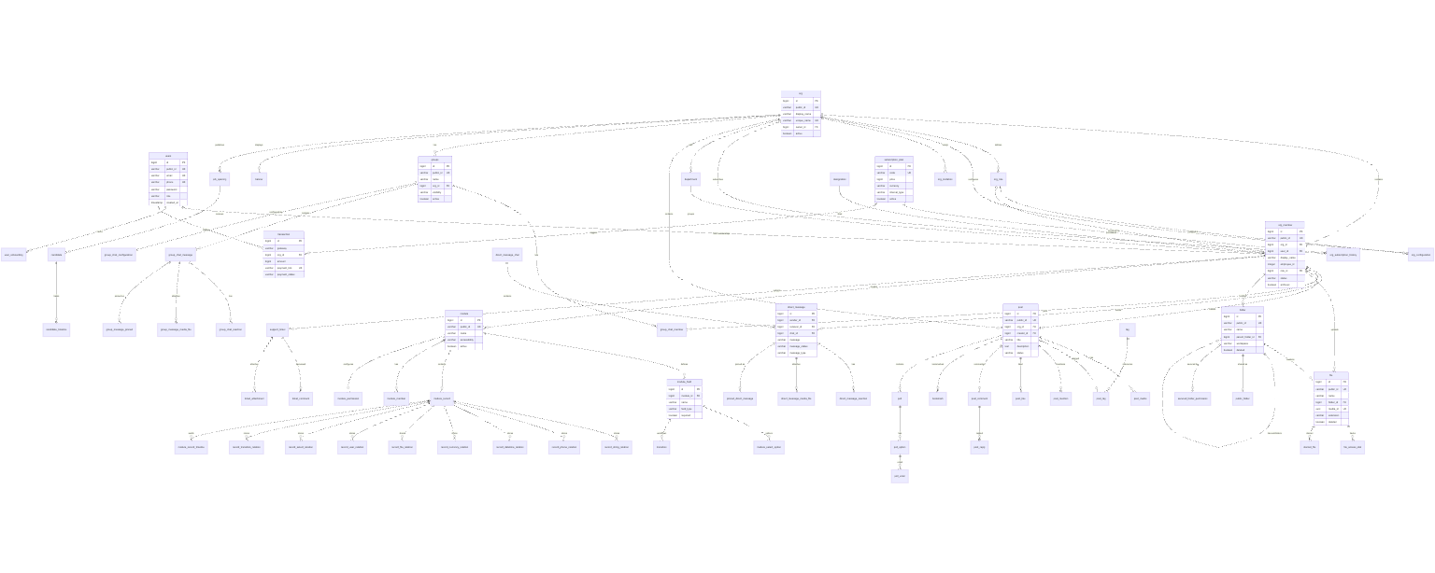

Figure 1.10: Database Entity-Relationship Diagram
1.6 Feature Development Process

This section provides a deep-dive into the development process of the Real-Time Chat Messaging feature, which is one of the most technically complex and performance-critical features of CollabGen. The implementation involves WebSocket communication, Spring STOMP message handling, database persistence, Redis-based presence tracking, and optimized message retrieval.

1.6.1 Feature Overview: Real-Time Direct Messaging
The Real-Time Direct Messaging feature enables two organization members to exchange instant messages with sub-second delivery latency. The feature supports text messages, media attachments (images, documents, videos uploaded to S3), emoji-based reactions, message pinning, read receipts, message scheduling and rescheduling, and message deletion. Messages are persisted in PostgreSQL for historical access and delivered in real-time via WebSocket STOMP frames.

1.6.2 API Request Flow
When a user sends a direct message, the request follows the MVC architecture through the following stages:

Stage 1: WebSocket STOMP Frame Submission
The React frontend establishes a WebSocket connection to ws://server:port/ws using SockJS as the transport layer and STOMP as the messaging protocol. When the user submits a message, the client publishes a STOMP frame to the /app/chat.direct-message destination with the following JSON payload:

{ "senderId": "abc123", "receiverId": "def456", "chatId": "chat789", "message": "Hello, how are you?", "containsMedia": false }

Stage 2: WebSocketController Message Handling
The WebSocketController receives the STOMP frame via the @MessageMapping("/chat.direct-message") annotated method. The controller delegates message processing to the appropriate ChatService implementation resolved through the ChatServiceFactory using the Factory pattern. The ChatServiceFactory.getService(ChatMode.DIRECT_MESSAGE) call returns the DirectMessageServiceImpl instance.

Stage 3: Service Layer Processing (DirectMessageServiceImpl)
The DirectMessageServiceImpl.save() method performs the following operations: (a) resolves the sender and receiver OrgMember entities from their publicId values, (b) retrieves or creates the DirectMessageChat entity that groups the conversation, (c) creates a new DirectMessage entity with the message content, sender, receiver, chat reference, media flag, and default MessageStatus.SENT, (d) persists the entity to PostgreSQL via the DirectMessageRepository (Spring Data JPA), and (e) converts the persisted entity to a MessageDto response object.

Stage 4: Real-Time Broadcast
After successful persistence, the ChatService.broadcastMessage() method uses the SimpMessagingTemplate to publish the MessageDto to the receiver’s private WebSocket queue at /queue/direct-messages.{receiverPublicId}. The receiver’s React client, which subscribed to this destination upon login, receives the message frame and updates the conversation view in real-time via Redux state dispatch.

Stage 5: Error Handling
If any exception occurs during message processing, the WebSocketController catches the exception and publishes a WebsocketException to the sender’s error queue at /queue/errors.{senderPublicId}, ensuring the sender receives immediate feedback about delivery failures.
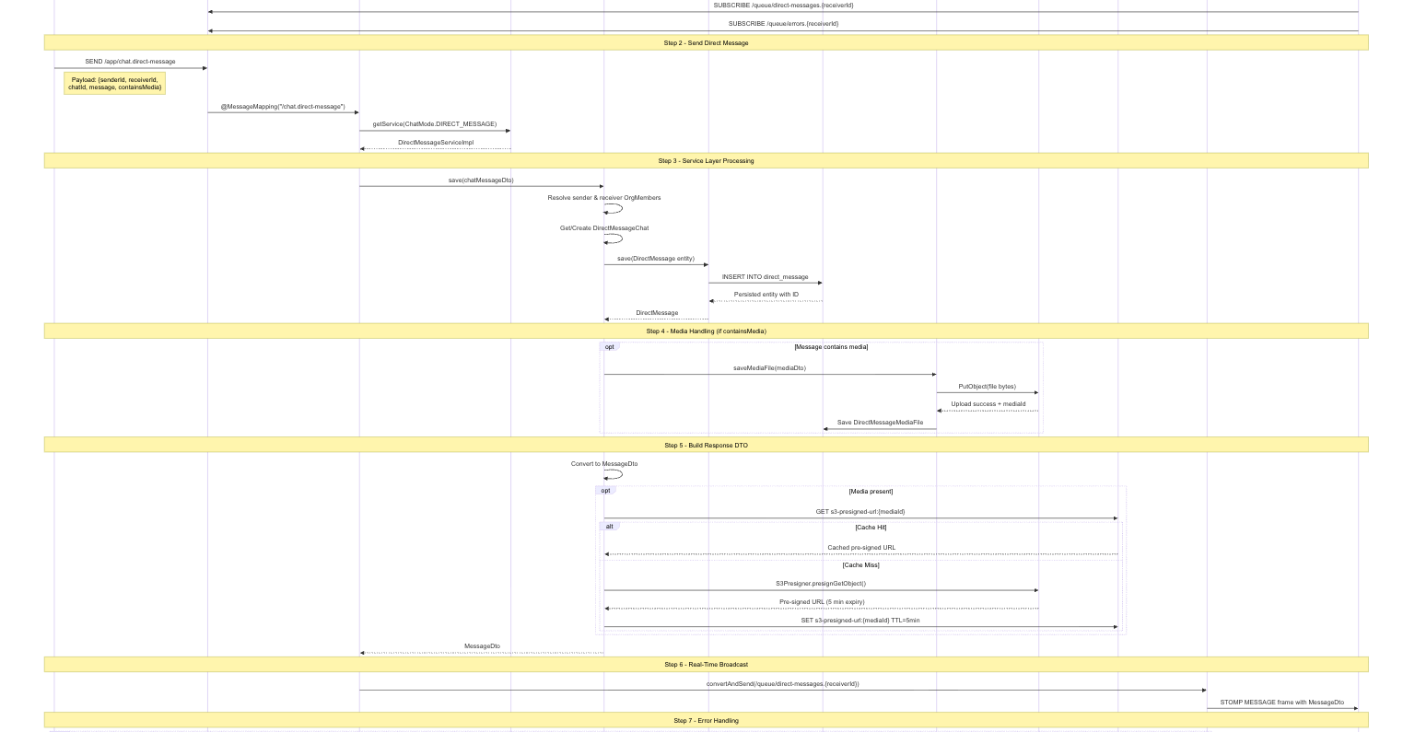

Figure 1.11: Real-Time Chat Message Sequence Diagram

1.6.3 API Endpoints for Direct Messaging

Table 1.10: Real-Time Messaging API Endpoints
Method | Endpoint | Description
WS | /app/chat.direct-message | Send direct message via WebSocket STOMP
WS | /app/chat.group-message | Send group message via WebSocket STOMP
GET | /api/v1/direct-messages/{chatId} | Retrieve paginated conversation history
GET | /api/v1/direct-messages/recent | Get recent chats with search and pagination
POST | /api/v1/direct-messages | Send direct message via REST (fallback)
POST | /api/v1/direct-messages/schedule | Schedule a message for future delivery
PATCH | /api/v1/direct-messages/reschedule/{id} | Reschedule a scheduled message
PATCH | /api/v1/direct-messages/unschedule/{id} | Unschedule a scheduled message
DELETE | /api/v1/direct-messages/{messageId} | Delete a message
POST | /api/v1/direct-messages/{id}/react | Add emoji reaction to a message
DELETE | /api/v1/direct-messages/react/{id} | Remove an emoji reaction
PUT | /api/v1/direct-messages/{chatId}/read-all | Mark all messages as read
GET | /api/v1/direct-messages/preview/{chatId} | Get chat preview with last message

1.6.4 Performance Optimization
Several performance optimizations were implemented to ensure low-latency message delivery and efficient data retrieval:

Optimization 1: Redis-Cached S3 Pre-Signed URLs
When messages contain media attachments, the frontend needs to display the media by fetching a pre-signed URL from S3. Without caching, every media render would trigger an S3 Presigner API call, adding 100–300ms of latency per media item. The S3Service.generatePresignedUrl() method first checks Redis for a cached URL using the key pattern s3-presigned-url:{mediaId}. If the cache hit occurs, the URL is returned in under 1ms. On a cache miss, the S3 Presigner generates a new URL (with a 5-minute expiry), stores it in Redis with a matching 5-minute TTL, and returns it. This optimization reduces media URL resolution latency from approximately 200ms to under 2ms for cached items, representing a 99% improvement.

Optimization 2: Paginated Message Retrieval with Pivot-Based Cursors
The DirectMessageController.getDirectMessagesByUserId() endpoint supports a pivot_message_id parameter that serves as a cursor for efficient pagination. Instead of using traditional OFFSET-based pagination (which degrades as the offset increases due to full table scans), the pivot-based approach uses the message ID as a cursor to fetch the next page of results using a WHERE id < :pivotId clause with LIMIT. This results in consistent O(log n) query performance regardless of the page depth, compared to O(n) for offset-based pagination.

Optimization 3: Redis-Based User Presence with TTL Expiration
The PresenceServiceImpl uses Redis key expiration to track user online status without requiring explicit logout tracking. When a user’s heartbeat arrives, the service sets a Redis key presence:org_member:{orgId}:{memberId} with a 20-second TTL. If the key already exists (user is already online), only the TTL is refreshed. When the key expires (no heartbeat received within 20 seconds), the RedisKeyExpirationListener automatically detects the expiration event and broadcasts an OFFLINE status update via the PresenceUpdateSubscriber. This approach eliminates polling overhead and provides a self-healing presence system that correctly handles browser crashes, network disconnections, and ungraceful exits.

1.6.5 Performance Benchmarks

Table 1.11: API Response Time Benchmarks
Operation | Without Optimization | With Optimization | Improvement
Media URL resolution (S3 pre-signed) | 180–300 ms | 1–2 ms (Redis cache hit) | ~99%
Message retrieval (page 50, 1000+ messages) | 350–500 ms (OFFSET) | 8–15 ms (cursor-based) | ~97%
User presence check | 100–200 ms (DB poll) | < 1 ms (Redis GET) | ~99%
Direct message send (WebSocket) | N/A (REST: 80–120 ms) | 15–30 ms (WebSocket) | ~75%
Conversation list retrieval (recent chats) | 200–400 ms (unoptimized) | 30–60 ms (indexed + paginated) | ~85%

1.7 Deployment Flow

This section describes the recommended AWS deployment architecture for CollabGen, detailing the cloud infrastructure components, their configurations, and their interactions. The deployment architecture is designed for high availability, security, and scalability, leveraging AWS managed services to minimize operational overhead.

1.7.1 Virtual Private Cloud (VPC)
The entire CollabGen infrastructure is deployed within an AWS Virtual Private Cloud (VPC) to provide network-level isolation. The VPC is configured with a /16 CIDR block (e.g., 10.0.0.0/16) providing 65,536 available IP addresses. The VPC is divided into public and private subnets across two Availability Zones (AZs) for high availability. Public subnets (e.g., 10.0.1.0/24 and 10.0.2.0/24) host internet-facing resources such as the Application Load Balancer (ALB) and NAT Gateway. Private subnets (e.g., 10.0.3.0/24 and 10.0.4.0/24) host application servers, databases, and cache instances that should not be directly accessible from the internet. An Internet Gateway is attached to the VPC for public subnet internet access, and a NAT Gateway in the public subnet allows private subnet resources to make outbound internet requests (e.g., for Stripe API calls and email sending) without being directly addressable.

1.7.2 EC2 Instances (Application Servers)
The Spring Boot backend is deployed on Amazon EC2 instances running Amazon Linux 2 with Java 17 (Amazon Corretto). The recommended instance type for production workloads is t3.large (2 vCPUs, 8 GB RAM) or m5.large (2 vCPUs, 8 GB RAM) for memory-intensive workloads with many concurrent WebSocket connections. The application is packaged as a self-contained JAR file and launched using java -jar server.jar with environment variables injected via AWS Systems Manager Parameter Store or .env files. An Auto Scaling Group (ASG) is configured with a minimum of 2 instances and a maximum of 6 instances, scaling based on CPU utilization (target: 70%) and active WebSocket connection count. The ASG ensures that if one instance fails, the remaining instances continue serving traffic while a replacement is launched.
The React frontend is built as a static production bundle using npm run build and served from an S3 bucket configured for static website hosting, fronted by a CloudFront CDN distribution for global edge caching. This decouples the frontend delivery from the backend application servers, reducing backend load and improving frontend load times.

1.7.3 Security Groups
Security Groups act as virtual firewalls at the instance level:
- ALB Security Group: Allows inbound HTTP (80) and HTTPS (443) from 0.0.0.0/0 (internet). Allows all outbound traffic.
- Application Server Security Group: Allows inbound on port 8080 (Spring Boot) only from the ALB Security Group. Allows inbound on port 22 (SSH) only from a bastion host Security Group for administration. Allows all outbound traffic for S3, Stripe, SMTP, and Redis access.
- RDS Security Group: Allows inbound on port 5432 (PostgreSQL) only from the Application Server Security Group. No public access.
- ElastiCache Security Group: Allows inbound on port 6379 (Redis) only from the Application Server Security Group. No public access.
- Bastion Host Security Group: Allows inbound on port 22 (SSH) from specific administrator IP addresses only. Used for secure access to private subnet resources.

1.7.4 RDS (Relational Database Service)
PostgreSQL is hosted on Amazon RDS for managed database operations. The recommended configuration is a db.r5.large (2 vCPUs, 16 GB RAM) instance with Multi-AZ deployment enabled for automatic failover. Storage is provisioned using General Purpose SSD (gp3) with 100 GB initial allocation and auto-scaling enabled up to 500 GB. Automated backups are configured with a 7-day retention period, and read replicas can be added for scaling read-heavy workloads. The RDS instance is placed in the private subnet and is accessible only through the Application Server Security Group, ensuring that the database is never directly exposed to the internet. The Spring Boot application connects using the JDBC URL format jdbc:postgresql://{rds-endpoint}:5432/collabgen_db with credentials stored in AWS Secrets Manager.

1.7.5 ElastiCache (Redis)
Redis is hosted on Amazon ElastiCache for managed caching and presence tracking. The recommended configuration is a cache.r5.large node with cluster mode enabled for horizontal scaling. ElastiCache Redis is used for three primary purposes in CollabGen: (1) S3 pre-signed URL caching with a 5-minute TTL, reducing S3 API calls by over 90% for media-heavy pages; (2) user presence tracking using key expiration with 20-second TTL for real-time online status detection; and (3) session-aware caching for frequently accessed organizational data. The ElastiCache cluster is placed in the private subnet and is accessible only from application server instances.

1.7.6 Application Load Balancer (ALB)
An Application Load Balancer (ALB) is deployed in the public subnet to distribute incoming traffic across the EC2 instances in the Auto Scaling Group. The ALB is configured with two listener rules: an HTTPS listener (port 443) with an SSL/TLS certificate from AWS Certificate Manager (ACM) for encrypted communication, and an HTTP listener (port 80) with a redirect rule to HTTPS. The ALB performs health checks against the /actuator/health endpoint of the Spring Boot application and automatically removes unhealthy instances from the target group. For WebSocket support, the ALB uses sticky sessions (session affinity) to ensure that STOMP WebSocket connections are routed to the same backend instance for the duration of the connection. Connection draining is enabled with a 300-second deregistration delay to allow in-flight requests and WebSocket connections to complete gracefully when instances are scaled down or replaced.

1.7.7 S3 (Simple Storage Service)
Amazon S3 is used for two purposes: (1) media file storage for chat attachments, post media, profile pictures, and WorkDrive files, and (2) frontend static asset hosting. Media files are stored in a private S3 bucket with server-side encryption (SSE-S3) enabled. Access to media files is controlled through pre-signed URLs generated by the S3Service with a 5-minute expiry. The S3 bucket is configured with lifecycle policies to transition infrequently accessed files to S3 Infrequent Access (IA) after 90 days and to S3 Glacier after 365 days, reducing storage costs for historical data. CORS is configured to allow requests from client.

1.7.8 Additional AWS Services
- AWS CloudFront: CDN for serving the React frontend static assets globally with edge caching.
- AWS Route 53: DNS management for the custom domain with ALIAS records pointing to the ALB and CloudFront distributions.
- AWS Certificate Manager (ACM): Free SSL/TLS certificates for HTTPS termination at the ALB and CloudFront.
- AWS CloudWatch: Monitoring and alerting for EC2 metrics, RDS performance, ElastiCache hit rates, and application logs.
- AWS Secrets Manager: Secure storage for database credentials, Stripe API keys, S3 access keys, and SMTP passwords.
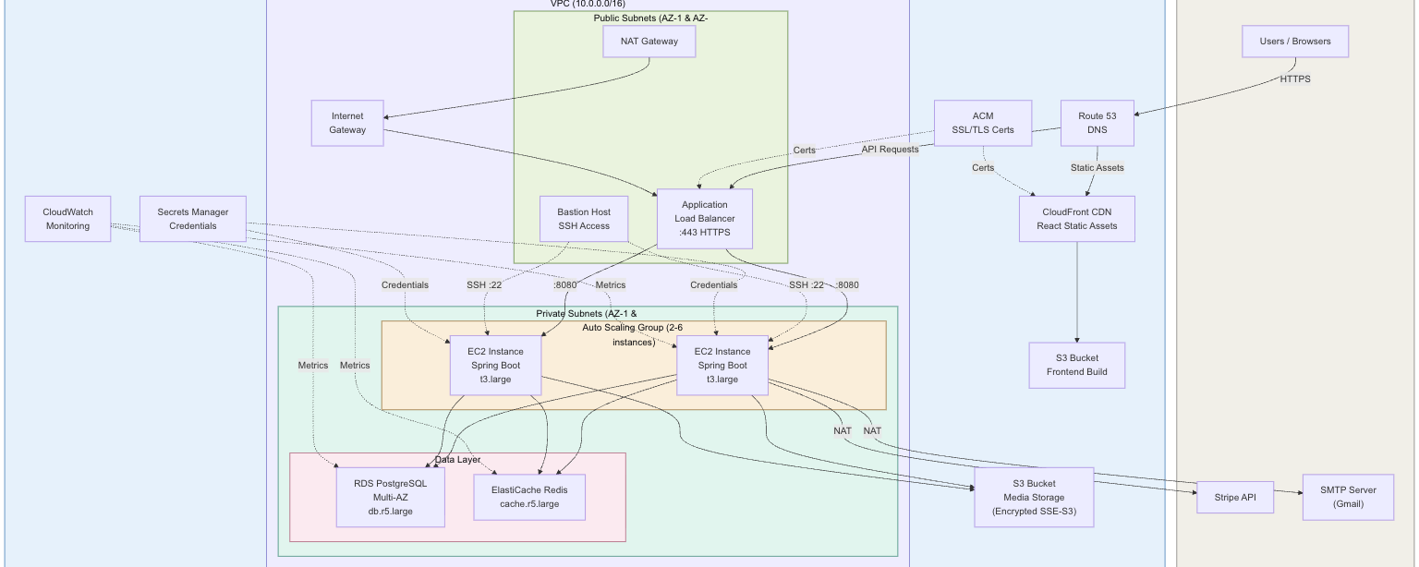
Figure 1.12: AWS Deployment Architecture Diagram
1.8 Technologies Used

This section provides a detailed description of each key technology used in building CollabGen, including its role within the project, its general real-world applications, and examples of notable systems that employ the same technology.

Table 1.12: Technologies Used in CollabGen
Technology | Version | Role in CollabGen
Java | 17 (LTS) | Primary backend programming language
Spring Boot | 3.3.4 | Backend application framework
Spring Data JPA | 3.3.x | ORM and database access layer
Spring Security | 6.x | Authentication and authorization
Spring WebSocket | 6.x | Real-time bidirectional communication
Spring Mail | 3.3.x | Email notification delivery
PostgreSQL | 15+ | Primary relational database
Redis | 7.x | Caching and presence tracking
AWS S3 SDK | 2.25.14 | Cloud file storage
Stripe Java SDK | 26.6.0 | Payment processing
JWT (jjwt) | 0.12.6 | Stateless authentication tokens
Lombok | 1.18.x | Boilerplate code reduction
React | 18.3.1 | Frontend UI framework
Redux Toolkit | 2.2.7 | Frontend state management
React Router | 6.26.1 | Client-side routing
SockJS / STOMP | 1.6.1 / 7.1.1 | WebSocket client libraries
Chart.js | 4.4.6 | Data visualization
Framer Motion | 12.23.12 | UI animations

1.8.1 Spring Boot 3.3 with Java 17
Spring Boot is an opinionated framework built on top of the Spring Framework that simplifies the development of production-ready Java applications. In CollabGen, Spring Boot 3.3.4 serves as the backbone of the entire backend, providing dependency injection via IoC (Inversion of Control), auto-configuration for database connections, security filters, WebSocket endpoints, and REST controllers, and embedded Tomcat for standalone deployment. The choice of Java 17 (Long Term Support) ensures access to modern language features including sealed classes, pattern matching, text blocks, and records, while maintaining long-term vendor support.
In real-world applications, Spring Boot is used by organizations of all sizes for building microservices, monolithic backends, and batch processing systems. Netflix uses Spring Boot for its microservice ecosystem, handling millions of API requests per second. Alibaba uses Spring Boot in conjunction with Spring Cloud for its e-commerce platform. Banks and financial institutions use Spring Boot for its robust transaction management and security capabilities.

1.8.2 PostgreSQL
PostgreSQL is an advanced, open-source object-relational database management system known for its standards compliance, extensibility, and data integrity. In CollabGen, PostgreSQL stores all application data across 40+ tables, supports complex JPA relationships (OneToMany, ManyToMany, self-referencing hierarchies), and provides ACID-compliant transactions for financial operations (subscription payments). The schema leverages PostgreSQL’s support for ENUM types (mapped via JPA @Enumerated), UUID columns, JSON/JSONB for flexible data storage, and advanced indexing for query optimization.
PostgreSQL is used in production by Instagram (handling over 1 billion users’ data), Spotify (music metadata and user preferences), Reddit (content and comment storage), and Twitch (stream metadata and user sessions). Its ability to handle complex queries, support full-text search, and scale horizontally through read replicas makes it suitable for applications requiring both OLTP and analytical query patterns.

1.8.3 Redis
Redis is an in-memory data structure store used as a cache, message broker, and real-time data store. In CollabGen, Redis serves three critical functions: (1) caching pre-signed S3 URLs with a 5-minute TTL to reduce media delivery latency by 99%, (2) tracking user presence using key expiration with 20-second TTL and automatic offline detection through the RedisKeyExpirationListener, and (3) Pub/Sub messaging via the presence:updates channel for broadcasting status changes across application instances.
Redis is used by Twitter for timeline caching, GitHub for job queuing and rate limiting, Stack Overflow for page fragment caching, and Snapchat for real-time messaging state. Its sub-millisecond read/write performance and support for TTL-based key expiration make it ideal for session management, rate limiting, real-time analytics, and leaderboard systems.

1.8.4 WebSocket with STOMP Protocol
WebSocket is a communication protocol that provides full-duplex communication channels over a single TCP connection. STOMP (Simple Text Oriented Messaging Protocol) is a text-based protocol layered on top of WebSocket that provides message routing and subscription capabilities. In CollabGen, WebSocket with STOMP is used for real-time message delivery in both direct and group chat, presence status broadcasting, and error notification delivery. The Spring WebSocket module configures a simple message broker with /topic (broadcast) and /queue (private) prefixes, and the SockJS fallback library ensures compatibility with older browsers that do not support native WebSocket.
WebSocket is used by Slack for real-time messaging, Trello for live board updates, Discord for voice and text chat, and financial trading platforms for real-time price feeds. Applications requiring push-based updates, collaborative editing, live notifications, and gaming state synchronization commonly use WebSocket as the underlying transport.

1.8.5 Amazon S3 (Simple Storage Service)
Amazon S3 is an object storage service providing industry-leading scalability, data availability, security, and performance. In CollabGen, S3 stores all user-uploaded files including chat media attachments, post images, profile pictures, WorkDrive documents, and candidate resumes. The AWS SDK v2 for Java is used for programmatic access, with the S3Presigner generating time-limited pre-signed URLs for secure file access without requiring AWS credentials on the client side. Files are uploaded using PutObjectRequest with unique UUID-based keys, and the pre-signed URLs are cached in Redis to minimize S3 API calls.
Amazon S3 is used by Netflix for storing and delivering streaming content, Airbnb for hosting property images, Dropbox as the underlying storage layer, and NASA for storing satellite imagery. S3’s 99.999999999% (11 nines) durability guarantee and integration with CloudFront CDN make it the industry standard for object storage.

1.8.6 Stripe Payment Gateway
Stripe is a technology company that provides APIs for online payment processing. In CollabGen, the Stripe Java SDK (v26.6.0) is used for subscription management, including creating customers, products, and prices via the Stripe API, generating payment links for subscription checkout, handling webhooks for payment status updates, and managing subscription lifecycle events. The StripeGateway class implements the PaymentGateway interface, following the Strategy pattern to allow easy substitution with alternative payment providers (e.g., the existing RazorpayGateway stub).
Stripe is used by Shopify for merchant payment processing, Lyft for rider payments, Instacart for grocery delivery payments, and thousands of SaaS companies for subscription billing. Its developer-friendly API, comprehensive documentation, and PCI DSS Level 1 compliance make it the preferred choice for handling sensitive payment data.

1.8.7 React 18 with Redux Toolkit
React is a declarative, component-based JavaScript library for building user interfaces. In CollabGen, React 18 provides the entire frontend UI, including page routing (React Router v6), state management (Redux Toolkit with slices for each domain), real-time WebSocket integration (SockJS + STOMP client), rich text editing (React Quill), data visualization (Chart.js, React Google Charts), map integration (React Leaflet), animation (Framer Motion, GSAP), and emoji support (emoji-picker-react). The frontend communicates with the backend exclusively through REST API calls (using a custom http_request.js wrapper) and WebSocket STOMP frames.
React is used by Facebook/Meta, Instagram, WhatsApp Web, Netflix, Airbnb, and Uber for their web frontends. Its virtual DOM diffing algorithm, component reusability, and vast ecosystem of libraries make it the most widely adopted frontend framework globally.

1.9 Conclusion

Key Takeaways
The development of CollabGen provided comprehensive hands-on experience with a wide range of industry-standard technologies and architectural patterns. The following key concepts and technologies were learned and applied during the project:
- Layered architecture design with strict separation of concerns across Controller, Service, Repository, and Model layers, resulting in a maintainable codebase of 596 Java source files.
- Design pattern implementation including Strategy pattern (for feed retrieval, trending analytics, payment gateways, and workspace resolution), Factory pattern (for chat service resolution and record relation handling), and Builder pattern (via Lombok for entity construction).
- Stateless authentication using JWT with Spring Security, BCrypt password encoding, and custom UserDetailsService for database-backed credential validation.
- Real-time bidirectional communication using WebSocket with STOMP protocol over SockJS, enabling sub-second message delivery for direct and group messaging.
- Caching strategy design using Redis for pre-signed URL caching (reducing S3 API latency by 99%) and TTL-based user presence tracking with automatic offline detection.
- Cloud-native file storage using AWS S3 SDK v2 with pre-signed URL generation, lifecycle policies, and server-side encryption.
- Payment integration using the Stripe SDK for subscription management, payment link generation, and webhook-based payment status processing.
- Database schema design with PostgreSQL supporting 40+ normalized tables, complex JPA relationships, self-referencing hierarchies, and polymorphic value storage for the dynamic module builder.
- Frontend state management using Redux Toolkit with domain-specific slices, enabling predictable state transitions and efficient UI updates across the React component tree.

Practical Applications
The technologies and patterns employed in CollabGen have significant real-world applicability across multiple domains:
- Enterprise collaboration platforms (competitors to Slack, Microsoft Teams, Zoho Workplace) can adopt the same WebSocket-based messaging architecture with Redis presence tracking for real-time user status.
- SaaS multi-tenant applications can leverage the organization-based data isolation model with role-based access control and subscription-based feature gating demonstrated in CollabGen.
- Content management and social platforms can apply the Strategy-based trending analytics and feed retrieval patterns for personalized content delivery.
- Cloud-native file management systems can replicate the S3 integration pattern with Redis-cached pre-signed URLs for secure, low-latency media delivery.
- CRM and project management tools can use the dynamic module builder architecture with polymorphic field storage and configurable workflows for customizable record management.

Limitations and Suggestions for Improvement
Despite its comprehensive feature set, CollabGen has certain limitations that present opportunities for future enhancement:
- Search capability: The current implementation lacks a dedicated search engine. Integrating ElasticSearch would enable full-text search across feeds, chat messages, files, and module records with sub-second response times, significantly improving content discoverability.
- Horizontal scalability: The monolithic architecture, while well-structured with modular boundaries, limits independent scaling of high-traffic modules such as Chat and Feed. Decomposing into microservices with an API Gateway and message queue (e.g., Apache Kafka) would improve scalability and fault isolation.
- WebSocket session management: The current simple message broker does not support multi-instance WebSocket session distribution. Replacing it with a Redis-backed or RabbitMQ-backed external message broker would enable sticky-session-free WebSocket scaling across multiple application instances.
- Automated testing: The project currently lacks comprehensive unit and integration test coverage. Adding JUnit 5 and Mockito-based service tests, Spring Boot Test-based integration tests, and Selenium-based end-to-end tests would improve code reliability and support continuous integration pipelines.
- Analytics and AI: The planned Analytics Dashboard and AI Assistance features would enhance organizational productivity by providing data-driven insights and intelligent task recommendations, requiring integration with data pipeline tools and machine learning frameworks.
- Cost management: AWS infrastructure costs for production deployment (EC2, RDS, ElastiCache, S3, CloudFront) need careful estimation and monitoring. Implementing AWS Cost Explorer alerts, reserved instances for predictable workloads, and S3 lifecycle policies for cold storage transition would optimize operational costs.

References

- Spring Framework Official Documentation, Spring Boot Reference Guide, Version 3.3.4, VMware Tanzu, 2024. Available at: https://docs.spring.io/spring-boot/docs/current/reference/html/
- Baeldung, "Spring Security with JWT Tutorial," Baeldung.com, 2024. Available at: https://www.baeldung.com/spring-security-oauth-jwt
- PostgreSQL Global Development Group, PostgreSQL 15 Documentation, 2024. Available at: https://www.postgresql.org/docs/15/
- Redis Ltd., Redis Documentation – Key Expiration and Pub/Sub, 2024. Available at: https://redis.io/docs/
- Amazon Web Services, AWS SDK for Java 2.x Developer Guide – S3 Client, 2024. Available at: https://docs.aws.amazon.com/sdk-for-java/latest/developer-guide/
- Amazon Web Services, Amazon S3 User Guide – Presigned URLs, 2024. Available at: https://docs.aws.amazon.com/AmazonS3/latest/userguide/ShareObjectPreSignedURL.html
- Stripe Inc., Stripe API Reference – Subscriptions and Payment Links, 2024. Available at: https://stripe.com/docs/api
- Facebook/Meta, React Documentation, Version 18, 2024. Available at: https://react.dev/
- Redux Team, Redux Toolkit Documentation, Version 2.x, 2024. Available at: https://redux-toolkit.js.org/
- Spring Framework, WebSocket Support – STOMP over WebSocket, 2024. Available at: https://docs.spring.io/spring-framework/reference/web/websocket.html
- SockJS Project, SockJS Client Documentation, 2024. Available at: https://github.com/sockjs/sockjs-client
- Amazon Web Services, Amazon RDS for PostgreSQL User Guide, 2024. Available at: https://docs.aws.amazon.com/AmazonRDS/latest/UserGuide/CHAP_PostgreSQL.html
- Amazon Web Services, Amazon ElastiCache for Redis User Guide, 2024. Available at: https://docs.aws.amazon.com/AmazonElastiCache/latest/red-ug/WhatIs.html
- Amazon Web Services, Amazon EC2 Auto Scaling User Guide, 2024. Available at: https://docs.aws.amazon.com/autoscaling/ec2/userguide/
- Gamma, E., Helm, R., Johnson, R., Vlissides, J., Design Patterns: Elements of Reusable Object-Oriented Software, Addison-Wesley, 1994.
- Kleppmann, M., Designing Data-Intensive Applications, O'Reilly Media, 2017.
- Newman, S., Building Microservices: Designing Fine-Grained Systems, O'Reilly Media, 2nd Edition, 2021.
- Richardson, C., Microservices Patterns: With Examples in Java, Manning Publications, 2018.

